#### Q-19. Write an SQL query to determine the 5th highest salary without using TOP or limit method.

#### SELECT * FROM (SELECT ROW_NUMBER() OVER (ORDER BY salary DESC) AS R_NUM, first_name, salary FROM employee) as HEllO WHERE R_NUM=5;

#### Q-20. Write an SQL query to fetch the list of employees with the same salary.

CREATE TABLE employee (

emp_id INT PRIMARY KEY NOT NULL,

first_name VARCHAR(50),

last_name VARCHAR(50),

salary INT

);

INSERT INTO employee VALUES

(1,'Luke','Skywalker',100),

(2,'Anakin','Skywalker',200),

(3,'Liea','Skywalker',100),

(4,'Rey','Skywalker',150),

(5,'Han','Solo',100),

(6,'Darth','Vader',150);

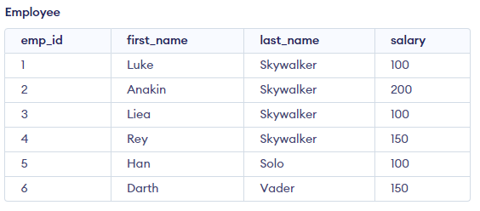

SELECT *

FROM employee

WHERE salary IN

(SELECT salary

FROM employee e

WHERE employee.emp_id <> e.emp_id);

#### 